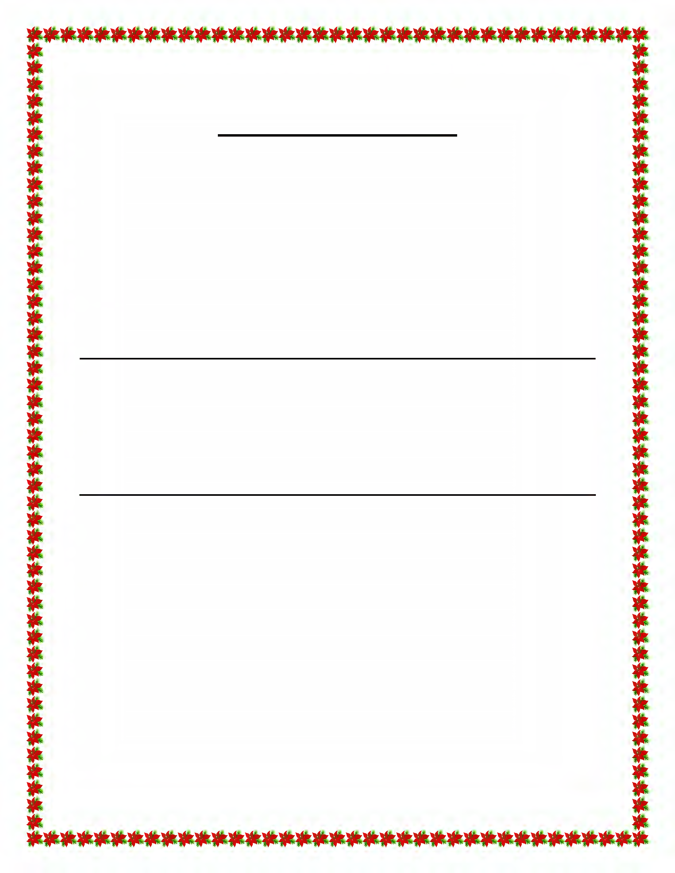REDINGTON BEACHES & INDIAN SHORES CHRISTMAS BOAT PARADE
Sunday, December 18, 2022 (Assemble at 5:45 pm)

BOAT REGISTRATION

Boat Name: FL Registration #:

Boat Length: Beam: Draft (Max 5’):

Boat Make: Power: Sail:

Owner’s Name:

Address: Home Phone #: Business or Cell #: Email address:

The undersigned shall indemnify and hold harmless the Town of Redington Beach, North Redington Beach, Redington Shores, Indian Shores and the Redington Beaches/Indian Shores Boat Parade Committee against any and all claims, liability or damages, including the cost of litigation and attorney’s fees, arising from the participation in the Redington Beaches/Indian Shores Boat Parade and all related activities.

Owner’s Signature: Driver’s License #:

- The Captain’s meeting is on Wednesday, December 14, 2022 at 7:00pm at Caddy’s Indian Shores located at 20025 Gulf Blvd, Indian Shores, FL 33785. Attendance is encouraged. Light refreshments served.
- Participants will be reimbursed for generator rental up to a maximum of $25.00 with proof of rental receipt. Reimbursement will be made from the Town Hall at North Redington Beach, 190 173rd Ave E., North Redington Beach, FL 33708.
- The rendezvous for the parade is at 5:45 pm on December 18th north of the Welch Causeway Bridge and east of Madeira Beach Recreation Center.
- For further information, contact the sponsoring organizations: Town of Redington Beach (391-3875), Town of North Redington Beach (391-4848), Town of Redington Shores (397-5538), and Town of Indian Shores (595-4020).
Please email, mail or fax the completed applications to:
Town of Redington Beach 105 164th Ave.
Redington Beach, FL 33708 FAX NUMBER: 727-397-6911
Email address: info@townofredingtonbeach.com

